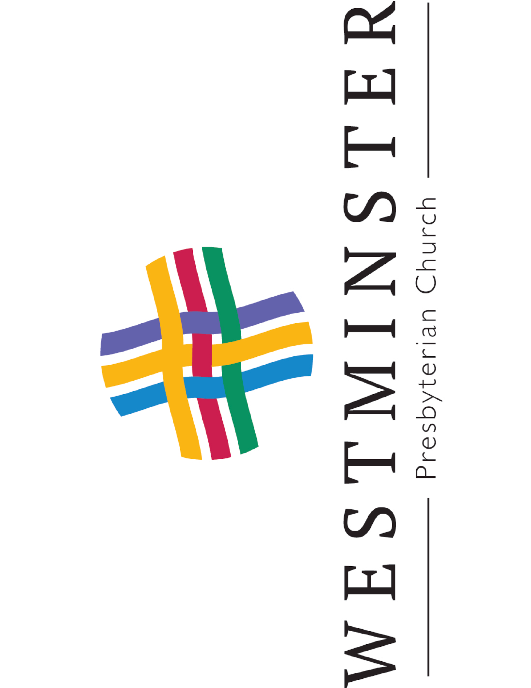

Albany, New York

March 10, 2024

Service of Worship 10:00 am

**WESTMINSTER PRESBYTERIAN CHURCH**

**The Fourth Sunday in Lent**

⌘ ⌘ ⌘

**Welcome to Westminster!** We’re glad you’re here.

* **If you’re visiting us this morning, we would love to meet you and greet you!**  We invite you to fill out the Welcome Card in the pew and put it in the offering plate or hand it to an usher in the back.
* **After worship, please join us downstairs as we continue our fellowship at our coffee hour.** We gather

in the hall located directly under the sanctuary. Stairs are located through the doors on either side of the front of the sanctuary, followed by another stairway that leads downstairs. Additional stairs and an elevator are available at the rear of the sanctuary. We recognize that our 19th century building can be confusing to navigate! **We are here to help**–please speak to an usher if you need assistance.

⌘ ⌘ ⌘

**WE ASSEMBLE IN GOD’S NAME**

*(Let the notes of our Prelude be the musical curtain through which we pass as we gather to worship together.*

*Let the preparation we make together be prayerful.)*

**Prelude**  “Beneath the Cross of Jesus”  Frederick C. Maker

(Arr. Victor Labenske)

**Call to Worship** Carolyn Smith

One: The Lord is merciful and gracious, *Psalm 103:8*

slow to anger and abounding in love.

**All: Let us worship God!**

**Opening Hymn** #826 Lift High the Cross

**Prayer of Confession**  Carolyn Smith

One: Are you thirsty for grace? Are you hungry for mercy? *Isaiah 55:1*

God is calling; come to the waters.

Trusting in God’s grace, let us confess our sin.

**All: God of mercy,**

**you sent Jesus Christ to seek and save the lost.**

**We confess that we have strayed from you**

**and turned aside from your way.**

**We are misled by pride,**

**for we see ourselves pure when we are stained,**

**and great when we are small.**

**We have failed in love, neglected justice,**

**and ignored your truth.**

**Have mercy, O God, and forgive our sin.**

**Return us to paths of righteousness**

**through Jesus Christ, our Savior.**

(Time of silence)

**Assurance of Forgiveness** Carolyn Smith

One: Listen, so that you may live:

The steadfast love of the Lord never fails

In the name of Jesus Christ, we are forgiven!

**All: Thanks be to God.**

**Passing The Peace** Carolyn Smith

**Words of Welcome** Rev. Heather Kirk-Davidoff

**Choral Anthem**  “Christ Is Our Cornerstone” E.H. Aufdemberg

**WE PROCLAIM GOD’S WORD**

**

Gracious God, our way in the wilderness,

guide us, by your Word, through these forty days,

and minister to us with your Holy Spirit,

so that we may reformed, restored, and renewed;

through Jesus Christ our Lord. **Amen.**



**Scripture** Number 21:4-9

From Mount Hor they set out by the way to the Red Sea, to go around the land of Edom; but the people became impatient on the way. The people spoke against God and against Moses, "Why have you brought us up out of Egypt to die in the wilderness? For there is no food and no water, and we detest this miserable food."

Then the LORD sent poisonous serpents among the people, and they bit the people, so that many Israelites died.

The people came to Moses and said, "We have sinned by speaking against the LORD and against you; pray to the LORD to take away the serpents from us." So Moses prayed for the people. And the LORD said to Moses, "Make a poisonous serpent, and set it on a pole; and everyone who is bitten shall look at it and live."

So Moses made a serpent of bronze, and put it upon a pole; and whenever a serpent bit someone, that person would look at the serpent of bronze and live.



**Psalm** Psalm 107:1-3, 17-22

**Sing: Hymn #653, Verse 1**

**Give thanks to God who hears our cries and saves in troubled day**

**with wondrous works to humankind that call for highest praise.**

**Let all who know God’s saving love sing grateful songs always.**

Leader: O give thanks to the LORD, for God is good;

God’s steadfast love endures forever.

**All: Let the redeemed of the LORD say so,**

**all who are redeemed from trouble and gathered in from the lands,**

**from the east and from the west, from the north and from the south.**

Leader: Some were sick through their sinful ways,

and because of their iniquities endured affliction;

they loathed any kind of food, and they drew near to the gates of death.

Then they cried to the LORD in their trouble,

and the Lord saved them from their distress;

the Lord sent out word and healed them, and delivered them from destruction.

**All: Let them thank the LORD for steadfast love,**

**for God’s wonderful works to humankind.**

**And let them offer thanksgiving sacrifices,**

**and tell of God’s deeds with songs of joy.**

**Sing: Hymn #653, Verse 6**

**So praise the One whose love is great, whose kindness is well-known.**

**Consider well the healing hand and help you have been shown.**

**and tell the world what God has done. Praise God and God alone!**

**Scripture** John 3:14-21

[Jesus said,] “And just as Moses lifted up the serpent in the wilderness, so must the Son of Man be lifted up, that whoever believes in him may have eternal life.

For God so loved the world that he gave his only Son, so that everyone who believes in him may not perish but may have eternal life. Indeed, God did not send the Son into the world to condemn the world, but in order that the world might be saved through him. Those who believe in him are not condemned; but those who do not believe are condemned already, because they have not believed in the name of the only Son of God. And this is the judgment, that the light has come into the world, and people loved darkness rather than light because their deeds were evil.

For all who do evil hate the light and do not come to the light, so that their deeds may not be exposed. But those who do what is true come to the light, so that it may be clearly seen that their deeds have been done in God."

**Sermon “**Doppelganger” Rev. Heather Kirk-Davidoff

**WE RESPOND TO GOD’S WORD**

**Prayer Hymn** #740 Lead Me, Guide Me (sung twice)

**Gathering Celebrations and Concerns**

**Prayer Hymn** #740 Lead Me, Guide Me (sung once)

**Prayers of the People** Rev. Heather Kirk-Davidoff

**The Lord’s Prayer**

**Our Father who art in heaven, hallowed be thy name.**

**Thy kingdom come, thy will be done, on earth as it is in heaven.**

**Give us this day our daily bread;**

**and forgive us our debts, as we forgive our debtors;**

**and lead us not into temptation, but deliver us from evil.**

**For thine is the kingdom**

**and the power and the glory, forever. Amen.**

**Offering**

**Hymn** #607Doxology

**Charge to the Congregation** Rev. Heather Kirk-Davidoff

**WE ARE SENT IN GOD’S NAME**

**

**Benediction**  Rev. Heather Kirk-Davidoff

**Postlude**  “The Old Rugged Cross” George Bernard

(Arr. Victor Labenske)

⌘ ⌘ ⌘

**Permission to reprint and stream the copyrighted music in this service is obtained from ONE LICENSE #A-700692, CCLI Streaming License #21525228 and/or CCLI Reprint #21525211. All rights reserved.**

**Stay in Touch with Westminster**

* Visit our website: [www.wpcalbany.org](https://www.wpcalbany.org/)
* Like us on Facebook: [Westminster Presbyterian Church Albany](https://www.facebook.com/wpcalbany)
* Get weekly news email messages by providing a current email address to the church office at office@wpcalbany.org or calling (518) 436-8544
* For more about Westminster’s online communications, please contact us: communications@wpcalbany.org

**2024 CHURCH OFFICERS**

**Session**

*Leah Threatte, Clerk of Session*

2024: Nancy Holroyd, Susan Schell

2025: Ephraim Adjei, Peter McKee, Linore Southworth

2026: John Bossung, Kate Gallagher, Felicia Kollie-Gambles, Nathan Powers

**Deacons**

*Mary Bullis and Dodie Seagle, Co-moderators*

2024: Ruthanne Brod, Cynthia Dwyer, Mabel McGraw

2025: Kelly Crisfield, Carolyn Smith

2026: Mary Bullis, Marie McClumpha, Dodie Seagle

**Trustees**

*John Bossung, President*

*Dixon Southworth, Vice President*

2024: David Adjei, Leif Hartmark, Laura Moody

2025: John Bossung

2026: Pete Seagle, Dixon Southworth, Joy L. Tallmadge, Peter Wrede

**CHURCH PROGRAM TEAM**

Rev. Heather Kirk-Davidoff, Pastor

[pastor@wpcalbany.org](mailto:pastor@wpcalbany.org)

Cell: 240-281-5005

Christopher Price, Music Director

[music@wpcalbany.org](mailto:music@wpcalbany.org)

Belinda Quaye, Director of Christian Education

[belindaquaye@wpcalbany.org](mailto:belindaquaye@wpcalbany.org)

Emma Mrowka, Organist

organist@wpcalbany.org

**CHURCH SUPPORT TEAM**

Lorraine Charboneau, Church Administrator

[office@wpcalbany.org](mailto:office@wpcalbany.org)

Kim Deal, Communications Manager

[communications@wpcalbany.org](mailto:communications@wpcalbany.org)

Forrest Holroyd, Treasurer

[treasurer@wpcalbany.org](mailto:treasurer@wpcalbany.org)

Joy L. Tallmadge, Associate Sexton

John Fox, Grounds Maintenance

**WESTMINSTER PRESBYTERIAN CHURCH**

262 State Street (Mail to: 85 Chestnut Street)

Albany, New York 12210

Office: (518) 436-8544

Email: [office@wpcalbany.org](mailto:office@wpcalbany.org) website: [https://wpcalbany.org](https://wpcalbany.org/)







